# [**Christopher Meloni & Mariska Hargitay Tease Stabler & Benson Reunion: “It’s On”**](https://deadline.com/2020/07/christopher-meloni-mariska-hargitay-tease-stabler-benson-reunion-its-on-1202989638/)

By [Denise Petski](https://deadline.com/author/dpetski/)

### [**Denise Petski**](https://deadline.com/author/dpetski/)

*Senior Managing Editor*

#### **More Stories By Denise**

* [Stacey Abrams, Desus & Mero To Guest Star In ‘Black-ish’ Animated Election-Themed Episode](https://deadline.com/2020/09/stacey-abrams-desus-mero-to-guest-star-in-blacklish-animated-election-themed-episode-1234585433/)
* [Samuel L. Jackson To Reprise Nick Fury Role In Marvel Series In The Works At Disney+](https://deadline.com/2020/09/samuel-l-jackson-reprise-nick-fury-role-in-marvel-series-in-the-works-at-disney-1234585334/)
* [‘Orange Is The New Black’ Alum Taryn Manning Signs With Pantheon](https://deadline.com/2020/09/orange-is-the-new-black-taryn-manning-signs-pantheon-1234584948/)

[**VIEW ALL**](https://deadline.com/author/dpetski/)

July 20, 2020 7:05am

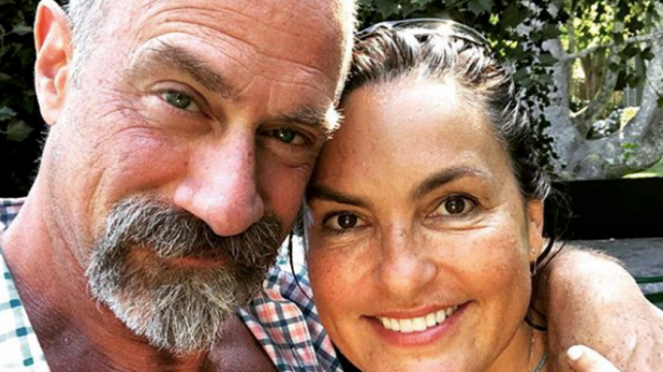

Mariska Hargitay via Instagram

[Mariska Hargitay](https://deadline.com/tag/mariska-hargitay/) and [Christopher Meloni](https://deadline.com/tag/christopher-meloni/) took to Instagram over the weekend to tease their reunion in the upcoming [*Law & Order: SVU*](https://deadline.com/tag/law-order-svu/) spinoff.

Hargitay posted a close-up photo of the two, simply captioned “It’s on.” As previously reported, the spinoff titled *Law & Order: Organized Crime* will be headlined by Meloni reprising his role as Elliot Stabler. Per the official logline, the spinoff will follow Stabler as he “returns to the NYPD to battle organized crime after a devastating personal loss.”

Meloni was last seen as Stabler at the end of season 12 of *Law & Order: SVU* in 2011. Meloni was the male lead opposite Hargitay, who plays Olivia Benson, for SVU‘s first 12 seasons, with their characters both partners and best friends. Stabler (Meloni) was last seen in the season 12 finale when he was involved in a shooting at the precinct. His character was written off in the season 13 premiere, with Stabler abruptly retiring from the police force.

Stabler is an Irish American who, during the time he was featured on SVU, was married (his wife Kathy was played by Isabel Gillies) with five children. The role earned Meloni a lead actor in a drama series Emmy nomination in 2006.

Production on the spinoff is expected to begin next month. *Law & Order: Organized Crime* will air Thursdays at 10 PM on NBC.

Check out Hargitay’s post below.

<https://www.instagram.com/p/CC2EXmFniR6/?utm_source=ig_embed>

Subscribe to [**Deadline Breaking News Alerts**](https://pages.email.deadline.com/signup) and keep your inbox happy.